CSE 283: Exam One

Name: ______________________________________ Section: _____ _____

Please write legibly. Ask questions if something is unclear. Be concise in written answers.
Exam is printed on both sides!

You may use a calculator and access the Java 2 Platform Std. Ed. 6.0 documentation at

http://java.sun.com/javase/6/docs/api/.

You may not use any other documentation or notes unless you want to get a zero for the exam. You must take the exam in pencil.

Some useful formulas:
d_{trans} = L/R d_{prop} = d/s

Questions:

- List the five protocol layers of the Internet in order from highest to lowest. (5 points)

_______________________,

_______________________,

_______________________,

_______________________,

_______________________,

- Host A contacts host B. After a handshaking protocol is completed, host A sends data to host B. Host B processes the data and stores it for later retrieval. (6 points)

In the above scenario, which host is the client and which is the server?

Client: _______________

Server: _______________

Why?
- Give definitions for the following terms using one or two sentences. If the term is an acronym, also state what the letters in the acronym stand for and give a definition.
(15 points)

a. Conditional Get:

b. mime Encoding:

c. Queuing Delay:

d. Traffic Intensity:

d. Out of band:

- List the two major architectures or paradigms used in designing the networked applications (4 points)

______________________________ ______________________________
(hint: they are both mentioned elsewhere in this exam.)
- Consider the following scenario:

Assume a web browser opens a TCP connection to a web server in order to download a web page. The browser sends a request message over the connection requesting the base HTML-file object. The web server responds by sending a response message containing the file. After receiving the response, the browser closes the connection. The browser parses the html file and finds nine referenced objects. To receive of the nine objects the browser sequentially requests a connection, sends a get message requesting the object, receives the object, and then closes the connection.

a. What type of HTTP connection is the browser using? (3 points)

b. Assuming zero transmission time for all objects, how many RTTs will it take to download the HTML file and the nine referenced objects? You do not need to account for closing messages. (Explain or show your reasoning.) (4 points)

c. What type of HTTP connections could the browser use to download the objects as fast as possible? (3 points)

d. Approximately how many RTTs would be required to download the web page and the nine referenced objects when using this faster method? (Explain or show your reasoning.) (4 points)

e. What transport layer protocol would the browser and webserver be using?
(4 points)

- Use the constants below to answer the following questions. Show work for partial credit. Indicate the units for each answer. Show three significant digits for time. Assume processing and queuing delays are negligible.

Bits being transmitted 30,000 bits
Packet Size 500 bits
Link Bandwidth 10,000 bps
Link Lengths 10,000 Meters
Propagation Speed 2.8 x 10⁸ Mps

- How long does it take to transmit a single bit? (2 point)

- Calculate the propagation delay for a single link. (4 points)

- Calculate the transmission delay for a single packet and a single router.
(4 points)

- Assuming there are five links connected by routers and that processing and queuing delays are negligible, calculate the time required for a single packet to travel from A to B at the end of the fifth link. (8 points)
A
B

- Where is the first bit in the first packet when the last bit in the first packet leaves A?
(3 points)

- Again, assume there are five links connected by routers and that processing and queuing delays are negligible. For pipelined transmission, calculate the time needed for the entire file to reach B at the end of the fifth link. (8 points)

- You are designing a networked application. It is a peer to peer application in which peers exchange real-time sensor data. Each peer should receive as many sensor data samples as possible from all the other peers. However, is not necessary for each peer to have every single data sample. Peers will operate best if the data they do process is received with as little time delay as possible. Which transport layer protocol would you use to support this application? Why? (5 points)

- Networks can be circuit switched or packet switched. Consider the characteristics below and identify which type of network the characteristic is associated with by writing either “P” for packet or “C” for circuit next to it as appropriate. (7 points)

______________ Aggregate resource demand can exceed available bandwidth.

______________ Reserved bandwidth for each connection.

______________ Stores and forwards discrete “chunks” of data.

______________ Network bandwidth is shared using statistical multiplexing.

______________ Connection setup required by the network.

______________ Network bandwidth divided into pieces using techniques such as TDM and FDM.

______________ Guaranteed time delay.

- Is the Internet a circuit or packet switched network? (3 point)

- Consider the following scenario:

A network application running on frodo.nps.edu wants to transmit packets for sam.muohio.edu. In the following, assume that all DNS servers (including the local name server) use caching and that all DNS caches initially contain bare minimal information. With the exception or the first query which should be handled recursively, assume all queries are handled iteratively. DNS server names are as follows:

TLD DNS server, edu: dns.tld.edu
TLD DNS server, org: dns.tld.org
Local DNS server, nps: local.nps.edu
Local DNS server, muohio: local.muohio.edu
Authoritative DNS, muohio: dns.muohio.edu
Authoritative DNS, nps: dns.nps.edu
Root DNS server: dns.root

- 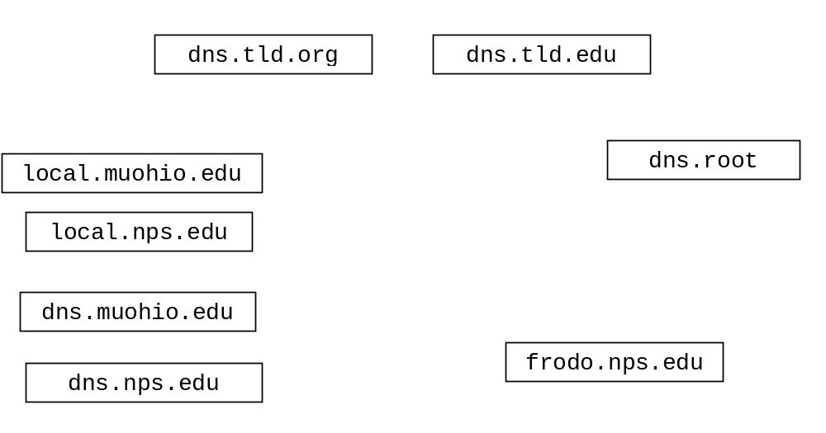Draw arrows labeled with numbers to indicate the order of queries and responses sent before frodo.nps.edu receives the IP address of sam.muohio.edu.
(12 points)

- Assume the sequence in the previous question has just occurred. Suppose an application running on gandalf.nps.edu wants to connect to sam.muohio.edu. What queries and responses will be necessary?(6 points)

- Assume the sequences in both the previous questions have occurred. Suppose an application running on pepin.nps.edu wants to connect to rosie.muohio.edu. What queries and responses will be necessary? (6 points)

- What transport layer protocol does DNS use? (4 points)

- Does the program at the bottom of the page define a client or a server? (6 points)

- On the next page, write a client or server as appropriate to communicate correctly with the program below. (It should multiply the all the numbers received and send back the product) Do not worry about handling exceptions. Throw them to the OS. (24 points)

import java.io.*;
import java.net.*

public class TCPProgram {

public TCPProgram () throws IOException
{
float numOne = 17.0, numTwo = 14.0, numThree = 4;

Socket socket = new Socket( "134.53.130.69", 6789);

DataOutputStream outTo =
new DataOutputStream(socket.getOutputStream());
DataInputStream inFrom =
new DataInputStream(socket.getInputStream());

outTo.writeFloat( numOne );
outTo.writeFloat( numTwo );
outTo.writeFloat( numThree );

double product = inFrom.readDouble();

System.out.println("Product received: " + product );

outTo.close();
inFrom.close();
socket.close();

}

public static void main(String[] args) throws IOException
{
new TCPProgram ();
}
}
public class OtherTCPProgram {

public static void main(String[] args) throws IOException
{
new OtherTCPTCPProgram ();
}

public OtherTCPTCPProgram () throws IOException
{
- Complete the Server class on the next page. Do not worry about handling exceptions. Allow the main method to throw all exceptions to the OS. (30 points)
- Clients send the Server two floats in a single packet using UDP. The first float is a base. The second number is an exponent.
- The server prints out the IP address and the port number of the socket the client used to send the floats.
- The Server raises the base to the exponent using the Math.pow method and sends this result back to the client as a double using UDP.
- When the result is less than one, the server will return it and then close down. Otherwise the server will continue to run and service other clients.
- The Server listens for clients on port number 9999.
- The Server handles clients sequentially.

import java.io.*;
import java.net.*;
import java.math.* ;

public class UDPPowerServer {

public static void main(String[] args) throws IOException
{
new UDPPowerServer ();
}

public UDPPowerServer () throws IOException
{

